# Worksheet 7a Reading from a file

# The text file people.txt is used in these questions:

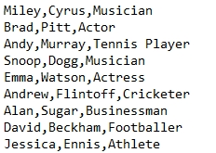

1. Use this code to predict which line of the file will be printed.

famousPeople = open("people.txt", "r")  
line = famousPeople.readline()  
line = famousPeople.readline()  
famousPeople.close()  
print(line)

Answer:

Now type up the program and test it to see if you were correct.

1. Use this code to predict which line of the file will be printed.

famousPeople = open("people.txt", "r")  
for counter in range(6):  
 line = famousPeople.readline()  
famousPeople.close()  
print(line)

Answer:

Now type up the program and test it to see if you were correct.

1. Add the statement print(line) somewhere in this program so that it will print out each line from the file, one at a time.

famousPeople = open("people.txt", "r")  
for counter in range(9):

line = famousPeople.readline()

famousPeople.close()

Now type up the program and test it to see if you were correct.

1. Complete the second line of this program so that it will print Emma Watson’s details.

file = open("people.txt", "r")  
for counter   
 line = file.readline()  
file.close()  
print(line)

Now type up the program and test it to see if you were correct.